**User Guide**

**Group members:**

Andrei Enoiu (253668)

Oleg Eni (253977)

**Project Supervisors:**

Jakob Knop Rasmussen (JKNR)

Kasper Knop Rasmussen (KASR)

***IT-SEP4C-S18 ICT ENGINEERING***

***4TH SEMESTER***

***07/06/2018***

**Introduction:**

This is the official User Guide for the “Crazy Maze” memorization training game. In the following pages you will get to learn every important aspect of the application, including UI functionality, rules and mechanics of the game.

**Rules:**

Win Condition: Complete all 4 goals

Lose Condition: Fail 1 of 4 goals

Goal 1: Reach the other end of the maze and remember key aspects of the natural environment you passed

Goal 2: Choose an item and make sure to remember it's number

Goal 3: Go back to where the start zone is by using your memory

Goal 4: Select the number of the item you previously chose

**Main Menu:**

To open the application, please click on the Crazy Maze icon in your application’s menu:

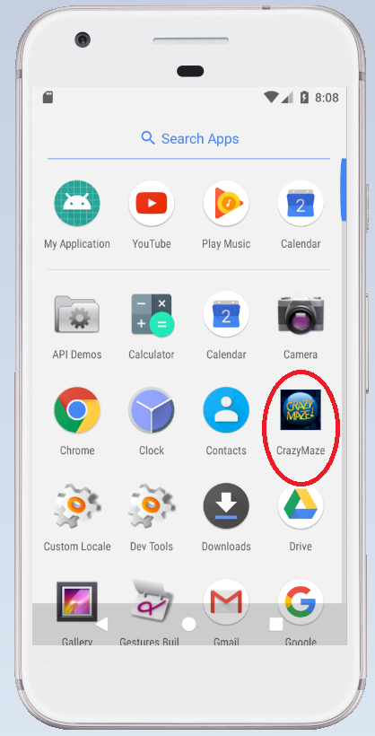

After a couple of seconds of loading, the main menu screen will open, looking like this:

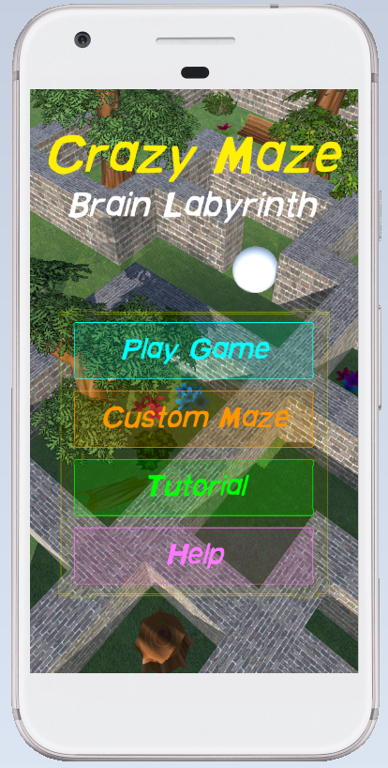

At the top of the screen, we have the names of the game (first the franchise, then the respective 1st game). Below, we have four buttons which the player can tap.

**Play Game:**

This button lets you choose from three levels that have an already created landscape, natural environment and textured walls based on the location.

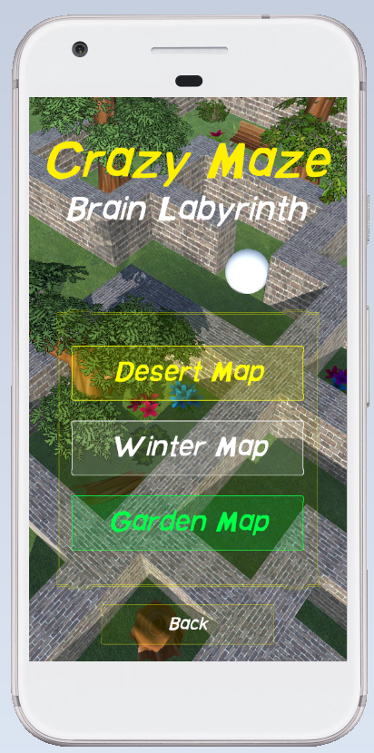

The Back button returns you to the original main menu screen.

**Desert Map:**

By tapping the Desert Map button, you select to play in a sand covered location with desert-like elements. We will talk more about gameplay & UI in the Gameplay Mechanics part.

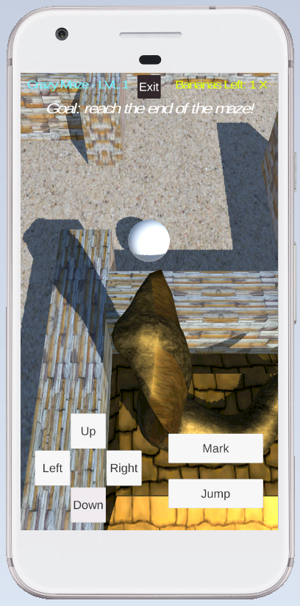

The White Ball in the middle is the Player object that you control.

**Winter Map:**

By tapping the Winter Map button, you select to play in a snow covered location with Christmas-like elements. We will talk more about gameplay & UI in the Gameplay Mechanics part.

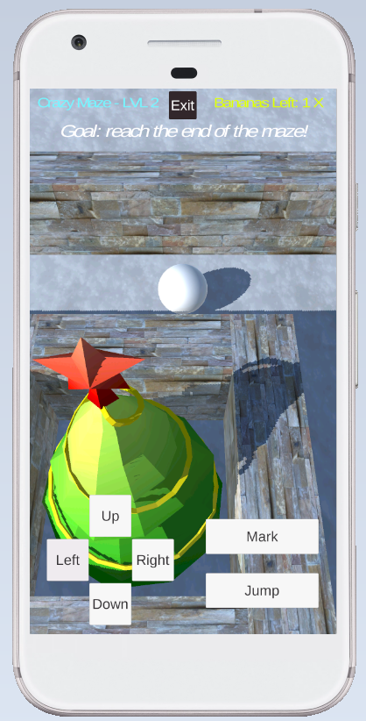

The White Ball in the middle is the Player object that you control.

**Garden Map:**

By tapping the Garden Map button, you select to play in a grass covered location with forest-like elements. We will talk more about gameplay & UI in the Gameplay Mechanics part.

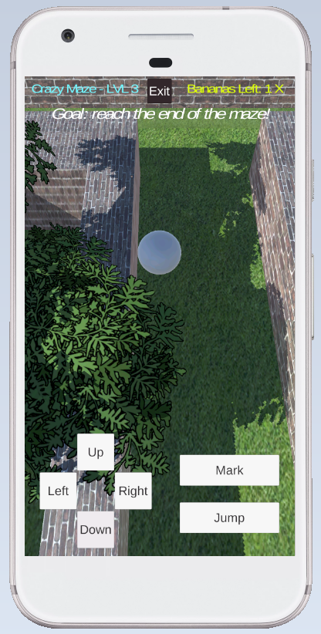

The White Ball in the middle is the Player object that you control.

Going back to the Main Menu, you have three additional buttons which you can tap:

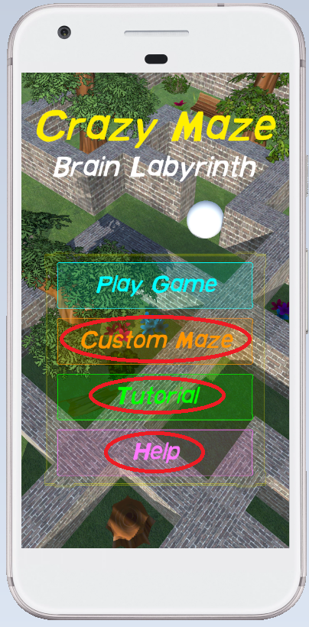

**Custom Maze:**

By tapping the Custom Maze button, you select to play in a randomly generated maze with no natural elements. We will talk more about gameplay & UI in the Gameplay Mechanics part.

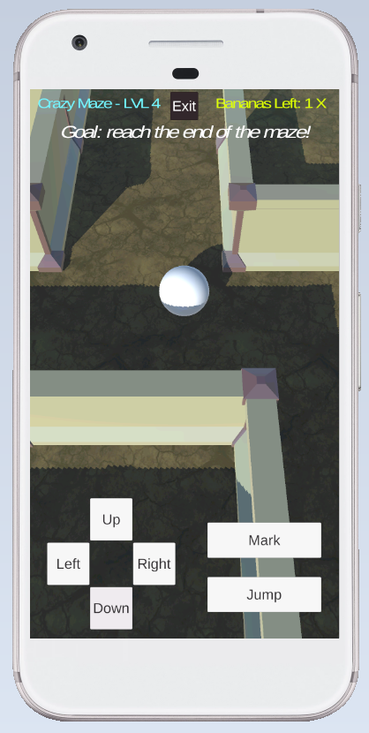

The White Ball in the middle is the Player object that you control.

**Tutorial:**

By tapping the Tutorial button, you select to play in a beginner’s maze with the purpose of learning the mechanics. We will talk more about gameplay & UI in the Gameplay Mechanics part.

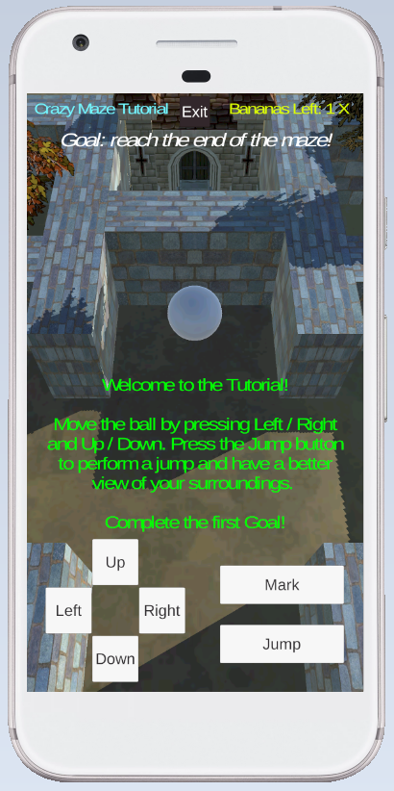

The White Ball in the middle is the Player object that you control.

**Help:**

By tapping the Help button, you select the helping screen which tells you the game’s Rules and objective conditions:

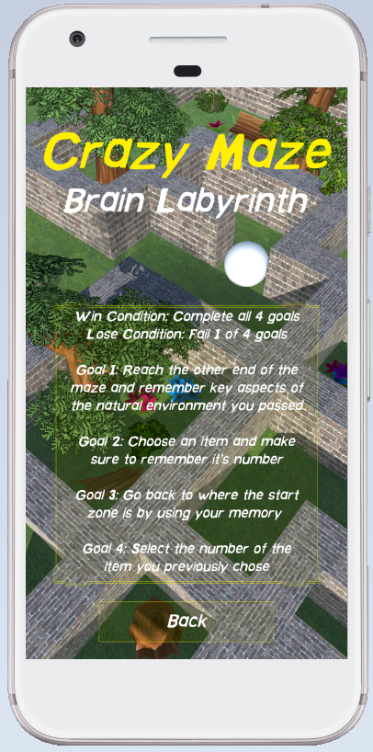

The Back button returns you to the original main menu screen.

**Gameplay Mechanics**

The following table contains all the controls that the player can use during the level. Note: same for all maps.

|  |  |
| --- | --- |
| **Button** | **Functionality** |
| Left | The player moves left |
| Right | The player moves right |
| Up | The player moves up |
| Down | The player moves down |
| Mark | The player drops a banana |
| Jump | The player performs a jump |
| Exit | The player exits to main menu |

At the top of the screen, you can see UI text information, such as the level of the game you are in, the numbers of bananas left that you can place, and also the goal you need to follow. Please remember that there are 4 goals which you need to accomplish in order to finish the mission. See next page for image.

Reminder: this game has the purpose of teaching you how to learn memorization in a fun and exciting way! Play & Enjoy!

